Lab53:
Stored Procedures:
Create a Store procedure:
Creating a stored procedure to insert a new employee record.
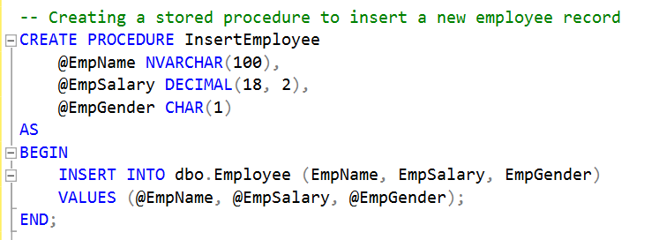
procedure named I nsertEmployee. accepts three parameters: @EmpName, @EmpSalary, and @EmpGender. It inserts a new record into the Employee table using the provided parameter values.

Modify a Stored Procedure:
Modifying the InsertEmployee stored procedure to include default values for parameters.
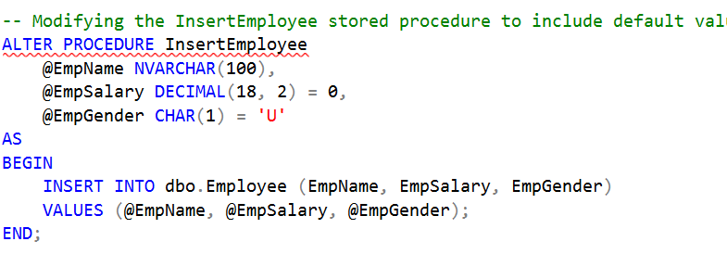
This script alters the existing InsertEmployee stored procedure. It adds default values for @EmpSalary and @EmpGender parameters.

Delete a Stored Procedure:
Deleting the InsertEmployee stored procedure.
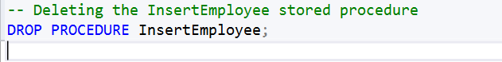

This script deletes the InsertEmployee stored procedure from the database.

Execute a Stored Procedure:
Executing the InsertEmployee stored procedure.
This script executes the InsertEmployee stored procedure. It provides values for the @EmpName, @EmpSalary, and @EmpGender parameters.

Return Data from a Stored Procedure:
Creating a stored procedure to retrieve employee details by ID.
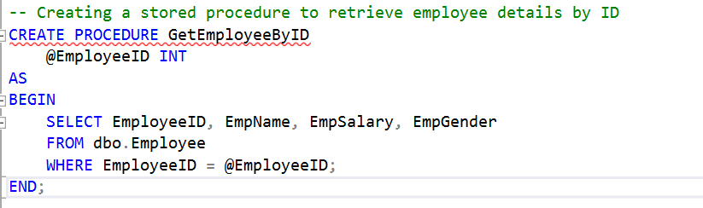
This script creates a stored procedure named GetEmployeeByID. It retrieves employee details based on the provided @EmployeeID parameter.
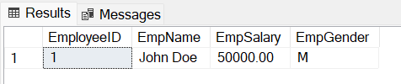

Rename a Stored Procedure:
Renaming the GetEmployeeByID stored procedure to FetchEmployeeByID.
This script renames the GetEmployeeByID stored procedure to FetchEmployeeByID.


Use Parameters in a Stored Procedure:
Creating a stored procedure with inpu.t and output parameters
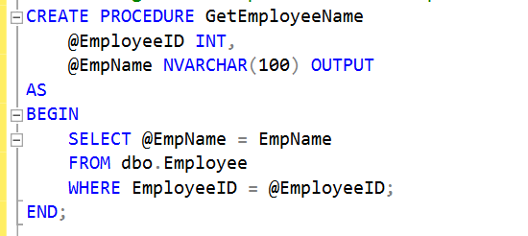
This script creates a stored procedure named GetEmployeeName with an input parameter @EmployeeID and an output parameter @EmpName.
It assigns the employee name to the @EmpName output parameter based on the provided @EmployeeID.

Executing with parameter:
Executing the GetEmployeeName stored procedure with an input parameter.
following executes the GetEmployeeName stored procedure with an input parameter and captures the output value in the @EmpName variable.
